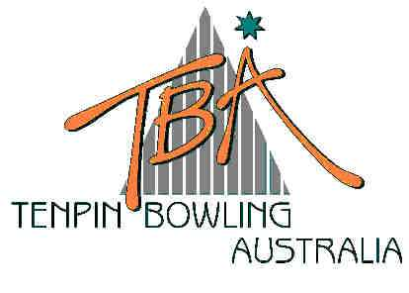
FOR IMMEDIATE RELEASE – Tuesday, 17 June 2003
Tenpin Bowling
Australia Limited
ABN 72 085 023 721

PO Box 280
Church Point NSW 2105

Website: www.tenpin.org.au
email: lynne.clay@tenpin.org.au

Phone: (61) 2 9880 8866
Fax: (61) 2 9880 8844
Mobile:0419 444 280

33rd AUSTRALIAN TENPIN BOWLING JUNIOR CHAMPIONSHIPS

Under 18-year old bowlers from every State and Territory in Australia – and even New Zealand - will soon be travelling to Melbourne to compete in the annual Junior National Championships of a sport that is increasingly popular with teenagers and young boys and girls throughout Australasia.

From 27 June to 13 July, AMF Forest Hill Bowl at Melbourne’s Forest Hill Chase Shopping Centre will be buzzing with bowling action. AMF’s state of the art Bowling Centre will host this year’s Championships, backed up by AMF’s Boronia Bowl in order to handle the expected record-breaking entries in this year’s event. Singles, Doubles and teams events are bowled throughout the hectic three-week schedule of these Championships, together with Graded and Open Masters events for Boys and Girls.

Adding to the excitement of pin-flying action are several individual and team events, including the popular National Intercentre Teams Cup, the Royal Rumble, and the Bumper Challenge. A colourful highlight of the Championships is the President’s Shield Trophy, an Interstate teams event staged over three consecutive days, commencing on Tuesday, 9 July.

The Junior Nationals is also the catalyst for Sports Science seminars, Anti-Doping Policy and Coaching forums etc. for officials, parents and guardians as well as junior bowlers. An important part of TBA’s role as the national governing body for the sport is its responsibility for the development and education of junior athletes. TBA works closely with, and is strongly supported by the Australian Sports Commission in every aspect of its role to regulate, develop and promote the sport of tenpin bowling in Australia.

The sport of tenpin bowling is one of just ten sports recently named by the Australian Commonwealth Games Association as part of the program for the II Commonwealth Youth Games, to be held in Bendigo from 29 November to 4 December 2004. Its inclusion on the program of this pinnacle multi-sport event for young athletes reflects the focus on young athletes by the sport’s administrators and supporters.

“Role models like Cara Honeychurch, and ’98 Commonwealth Games team-mates Maxine Nable, Michael Muir and Frank Ryan…these and many other elite athletes are an inspiration to young bowlers who now have a unique pathway extended to them” said TBA Chairperson, June Voukolos. “TBA’s Junior Nationals is an important milestone on that pathway” she added.

SEE LIVE SCORES AND RESULTS THROUGHOUT THE NATIONALS ON www.tenpin.org.au

ends

For further information, please contact TBA Media Director, Lynne Clay on 0419 444 280
or email lynne.clay@tenpin.org.au

