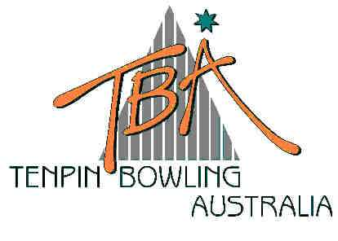
FOR IMMEDIATE RELEASE – Tuesday, 8 July 2003
Tenpin Bowling
Australia Limited
ABN 72 085 023 721

PO Box 280
Church Point NSW 2105

Website: www.tenpin.org.au
email: lynne.clay@tenpin.org.au

Phone: (61) 2 9880 8866
Fax: (61) 2 9880 8844
Mobile:0419 444 280

CLASSY PERFORMANCES IN CLASSIC CUP

The 33rd Junior Tenpin Bowling National Championship is an umbrella tournament encompassing a series of individual events catering for young bowlers with a range of skills.

Today’s Junior Classic Cup, a scratch event for players with an average no more than 180 for Boys and 170 for Girls, gave six teenagers from five States the thrill of experiencing the winner’s podium.

18 year-old Wade Jones from Kirwan in Townsville shot an impressive 255 High Game in Game 1 of the eight-game event and went on to card a 1565 total and 195.6 average. An Engineering student at James Cook University, Jones won the Classic Cup in 2001 and will be representing North Queensland in the prestigious interstate Teams event - the President’s Shield – that commences tomorrow.

Although only bowling for two years and in his first appearance at the TBA Junior Nationals, local bowler Andrew Tonkin from Heidelberg West gave Jones a real run for his money, scoring a 1544 total, with Townsville teenager Zach Waters from Kirwan a close third on 1529.

16 year-old Kelly Foreman from Largs Bay in Adelaide was declared the winner of the Girls division on completion of Game 8 with a total pinfall of 1483 and match average of 185.4. Bowling for just five years at Village Bowl in Golden Grove and AMF Woodville Bowl, Kelly is very focussed on her sport, bowling in two leagues a week and training almost every day. Fiona Smydzuk from Peakhurst in Sydney was second on 1441, just edging out Emily Kilgren from the Perth suburb of Beldon just six pins behind with 1435 . .

Play resumes tomorrow with Day One of the three-day President’s Shield and the resumption of Singles and Doubles squads in this popular annual Championship.

Results for today’s Junior Classic Cup can be viewed on the website of the sport’s national governing body, Tenpin Bowling Australia – www.tenpin.org.au

ends

For further information, please contact TBA Media Director, Lynne Clay on 0419 444 280
or email lynne.clay@tenpin.org.au

