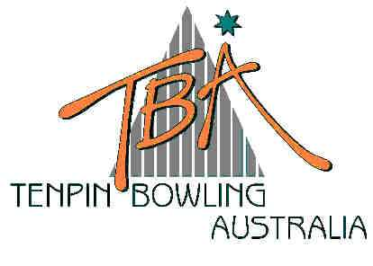
FOR IMMEDIATE RELEASE – Sunday, 6 July 2003
Tenpin Bowling
Australia Limited
ABN 72 085 023 721

PO Box 280
Church Point NSW 2105

Website: www.tenpin.org.au
email: lynne.clay@tenpin.org.au

Phone: (61) 2 9880 8866
Fax: (61) 2 9880 8844
Mobile:0419 444 280

HIGH FIVES AND HIGH SCORES AT
AUSTRALIAN TENPIN BOWLING JUNIOR NATIONAL CHAMPIONSHIPS

High fives and high scores are the order of the day at the 2003 TBA Australian Tenpin Bowling Junior National Championships currently underway in Melbourne. Now in their second week, the Championships have attracted under-18 year-old bowlers from all around Australia to compete in the pinnacle event of the sport’s junior tournament calendar.

The lanes at AMF’s Forest Hill and Boronia Bowling Centres are crowded from early morning and through until late each night as additional squads continually fill with young bowlers eager to qualify for the prestigious title of champion.

Now in its 33rd year, the popularity of the annual Junior Nationals is demonstrated by the steady increase in entries, and this year’s event is on target to break records.

An outstanding performance by 14 year-old Michael Craig during yesterday’s qualifying rounds of the National Intercentre Cup at Boronia Bowl notched a personal best 289 game for the Monash teenager, who entered this year’s Nationals with a league average of just 126. Craig is part of the ACT Vikings team that won the National Intercentre Cup in Brisbane in 2001 and Sydney in 2002 and his near-perfect game augurs well for the team’s tilt at their third consecutive win.

Another memorable personal best score of 279 has rocketed local 17 year-old Shaun Parlby from the Melbourne suburb of Croydon into the top qualifying spot for the elite Australian Open Masters. His three-game series of 709 has raised the bar and Parlby looks certain to make the cut to the top 32 for the double-elimination Open Masters that will be contested next weekend at Forest Hill Bowl.

The final rounds of pin-flying action at the National Intercentre Teams Cup at Boronia this afternoon will be followed this evening at Forest Hill by the Royal Rumble, a “Baker” style team-of-five event where player one bowls frames 1 and 6, player 2 bowls frames 2 and 7 etc.

Close scoring and high fives all round add to the electric excitement of these two popular Teams events. The hectic schedule of bowling continues until Sunday, 13 July and spectators are welcome to witness the excitement and skill of these young bowlers here in Melbourne all week.
SEE LIVE SCORES AND RESULTS THROUGHOUT THE NATIONALS ON www.tenpin.org.au

ends
For further information, please contact TBA Media Director, Lynne Clay on 0419 444 280
or email lynne.clay@tenpin.org.au

