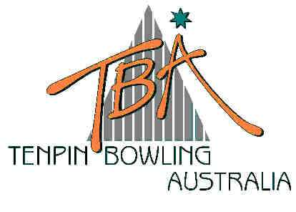
FOR IMMEDIATE RELEASE – Monday, 7 July 2003
Tenpin Bowling
Australia Limited
ABN 72 085 023 721

PO Box 280
Church Point NSW 2105

Website: www.tenpin.org.au
email: lynne.clay@tenpin.org.au

Phone: (61) 2 9880 8866
Fax: (61) 2 9880 8844
Mobile:0419 444 280

THE FUN ELEMENT
AUSTRALIAN TENPIN BOWLING JUNIOR NATIONAL CHAMPIONSHIPS

The success of the 33rd Australian Tenpin Bowling Junior National Championships can be measured in two ways – a sea of happy faces and near record entries.

A unique appeal of the sport of tenpin bowling is the “fun “ element, and the excitement and challenge of close to a fortnight of full-on bowling action shows in the happy smiles of hundreds of young bowlers who have descended on Melbourne to participate in this year’s “Nationals”. Singles, Doubles and Teams events are underway at the spectacular AMF Forest Hill Bowl in Melbourne, providing a variety of events and activities for bowlers and officials alike.

Today’s highlight event was the Restricted Cup – a Handicap event for bowlers whose averages are 170 and under for Boys and 160 and under for Girls.

Following the Stage One Elimination Final, the top 16 bowlers in each division on total scratch plus entering handicap pinfall advanced to Stage Two. Each match of Stage Two was contested over two games, with scratch pinfall plus entering handicap determining the winner.

In the Girls division, 13 year-old Elle Cocks of Mt. Isa swept to the winners podium undefeated in seven rounds with a 231.7 average with handicap. Elle bowled an outstanding final series, defeating Devonport’s Caitlin Burk 485-296, with Ashley Bulow from Warrabrook Lakes third.

Another Devonport bowler, 16 year-old Alex Booth won the Boy’s division in a final match of 496-464 after being taken to eight rounds by Adelaide teenager Matt Trevarthen from Elizabeth North. The third Devonport bowler to feature in the Restricted Cup placings, Matthew Davis finished in third place.

The pin-flying action continues tomorrow at AMF Forest Hill Bowl when the Classic Cup starts at 9am. Spectators are welcome. Full results for today’s Restricted Cup and all scores to date can be viewed on the website of the sport’s national governing body, Tenpin Bowling Australia – www.tenpin.org.au

ends

For further information, please contact TBA Media Director, Lynne Clay on 0419 444 280
or email lynne.clay@tenpin.org.au

